**Tech Assignment**

(05) A government agency and a community partner that provide resources and guidance for environmental stewardship and a detailed analysis of what they are *actually* doing (not just based on their own website data). (D1.4)

Presentation Link:

<https://www.canva.com/design/DAFzdHodVUc/RibfRmBW0v8AEJX3IgA4-w/edit?utm_content=DAFzdHodVUc&utm_campaign=designshare&utm_medium=link2&utm_source=sharebutton>

(List sources at the bottom of the notes)

Environmental Stewardship Definition: The ethical use and preservation of the environment through sustainable methods that increase ecosystem resilience and improve human well-being.

Different Types of Stewardship:

Restoration and Protection: Taking steps to help restore or protect a deteriorated, damaged, or destroyed ecosystem while allowing it to evolve with little interference from humans.

-Restoring a local ecosystem

-Removing invasive plants

-Cleaning up litter

-Developing a sustainable greenspace

Everyday Choices: Reductions in resource inputs and emissions per unit of output brought about by technology advancement and consumer purchasing, using, and disposal habits.

. -Compositng food and Yard waste

-Starting some sort of a recycling project/system

-Implementing energy-saving techniques or alternative energy sources

Community Awareness: Informing people in an effort to persuade them to take action to resolve local environmental problems

-Sharing information and creating posts online

-Posters at events

-Broadcasting public service announcements

-Organizing events about the topic

---------------------------------------------------------------------------------------------------------------------

The following government departments and organizations offer tools and advice for environmental stewardship:

Crown-Indigenous Relations and Northern Affairs Canada receives local guidance on federal environmental and environmental assessment laws from the Environmental Stewardship and Policy team.

The B.C. Stewardship Centre offers advice and technical help to community organizations and private stewards.

The funding for aquatic stewardship programs is managed by Fisheries and Oceans Canada.

The funding for projects promoting terrestrial stewardship is managed by Environment and Climate Change Canada.

Electronic Waste Disposal:

What is E-Waste : Electronic waste describes discarded electrical or electronic devices. Other terms that are also commonly used instead of E-Waste are, waste electrical and electronic equipment and even end-of-life electronics. Electronics that are considered e-waste include used electronics which are meant to be refurbished, reused and resolved but are found recycling through material recovery or disposal. E-waste is created when an electronic product is discarded after the end of its lifecycle.

The United States Environmental Protection Agency (EPA) classifies e-waste into ten categories:

* Large household appliances, including cooling and freezing appliances
* Small household appliances
* IT equipment, including monitors
* Consumer electronics, including televisions
* Lamps and luminaires
* Toys
* Tools
* Medical devices
* Monitoring and control instruments
* Automatic dispensers

Government of Ontario:

A new rule that the Ontario government has introduced will force manufacturers of electrical and electronic devices, including computers, game consoles, printers, and cell phones, to gather and securely manage the entirety of the equipment's life-cycle. This regulation was put into place and started to become enforced on January 1, 2021.

This requirement will allow innovative solutions to the problem of managing electronic waste as well as significantly reducing e-waste.

"Electronics are becoming an increasing challenge for our waste system and we need new solutions to keep them out of landfills," said Jeff Yurek, Minister of the Environment, Conservation and Parks.

From this rule, 2 companies joined together (Nokia and Greener Acers Canada) to help prevent electronic waste and promote recycling. Their project includes recycling electronics and using them to create Smart City Green poles and help to enable high-speed broadband. Greener Acers produces up to 1,000 smart city green poles every day. Because of the relationship between Nokia and Greener Acers, many jobs have been created.

"Companies like Nokia and Greener Acres are finding new and innovative ways to manage their products, make recycling simpler and put these recyclable materials back into the economy. I hope to see many other creative ideas coming forward over the coming months that will significantly reduce the amount of electronics from going to landfill," said Minister Yurek.

More information on Nokia and Greener Acers Canada :

This initiative will help create smart city green poles from close to 48,124 tons of e-waste which is collected annually in Ontario. These smart green poles as mentioned before will deliver high-speed broadband communications.

This agreement between the 2 companies was signed to reduce e-waste as well as help foster intelligent urban infrastructure solutions, help enhance communications and create a more circular economy inside of Canada.

Cities that have these new poles are also able to transform into more of a smart city. They can use these poles and create better infrastructure, loT devices, sensors to power street lights, metered parking, wastewater systems and much more.

“Jeff Yurek, Minister of the Environment, Conservation and Parks, Ontario, said: ‘As people upgrade their phones, computers, tablets, gaming consoles, and other electronic items, we need to find new ways to keep e-waste out of landfills and reduce its impact on our environment. Nokia and Greener Acres have come up with a very exciting plan to turn this waste into a new resource for building smart cities that will benefit all Canadians and support a circular economy.’” (Nokia,2020)

Electronic Products Recycling Association (EPRA) :

EPRA is a non-profit organization that helps to manage government-approved programs that are created and established by manufacturers, retailers (etc) to properly collect and recycle electronics that are no longer used and are at the end of their lifespan.

Manufacturers, retailers (etc) of regulated electronic products inside of British Columbia, Alberta, Saskatchewan, Manitoba, Ontario, Quebec, Nova Scotia, Prince Edward Island, Newfoundland & Labrador, New Brunswick, Northwest Territories and Yukon with provincial extended producer responsibility regulations have to be active in an approved product stewardship plan.

Recycle my Electronics (Ontario) :

They are a national not-for-profit organization that ensures electronics recycling all over Canada. The manage the largest network of processor transports as well as drop-off locations for e-waste across Canada.

They work all across diverse regulatory landscapes and ensure e-waste is properly collected and sorted, handled and recycled in a safe and environmentally friendly manner.

Recycle My Electronics has been active for over 10 years and they have been able to successfully and securely recycle over 1 million tonnes of electronic waste.

They recycle items such as Display devices, Drones, Home Audio/Video Systems, Desktop Computers, Home Theatre in-box (HTB) Systems, Cameras And security cameras and many more electronics.

Recycle My Electronics also helps out businesses. You can schedule e-waste pick-ups for businesses. This is done at low-to-no-cost services. They are able to work right with businesses in finding proper e-waste recycling solutions that suit them.

There is a Recycle my Electronics location just down on 5750 Explorer Dr, Mississauga, ON L4W 5P6.



There are also many other locations all across Toronto.

Popular reviews from people:

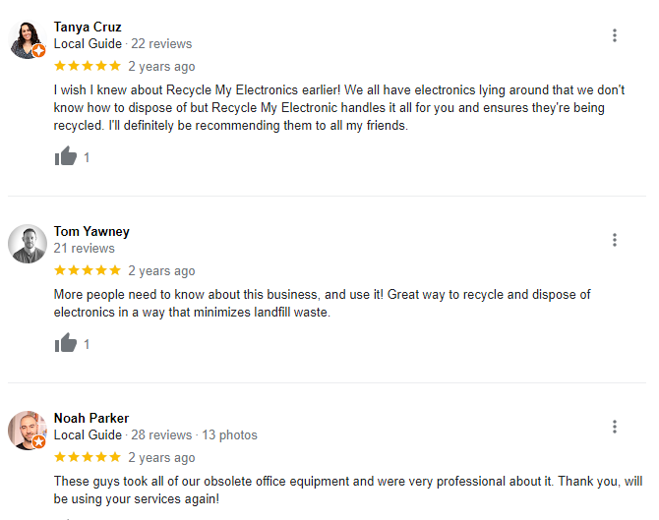

---

An example of an award that was won by EPRA (but this is in Saskatchewan) is when they were recognized by the Saskatchewan Waste Reduction Council (SWRC) as the winners of the Waste Minimization Award in the Non-Profit Organization category.

The Electronic Products Recycling Association (EPRA) was awarded the 2015 – Business/ Organization Category; Canadian Stewardship Award at the Conference on Canadian Stewardship held in Banff, Alberta.

---------------

IT reported the supply of 14,151,049 regulated electronic products into the province (British Colombia). During 2021, we collected a total of 14,042 metric tonnes of end-of-life electronics.

British Colombia EPRA BC - 2021

A part of stewardship is community awareness. These are some of the public relations coverage they have done throughout the year.

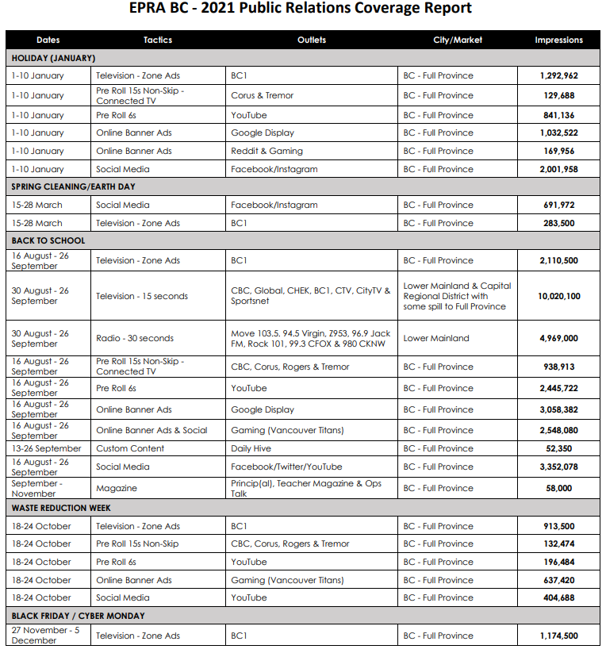

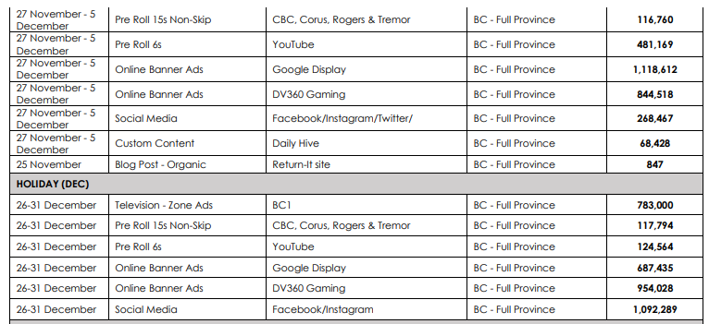

ERA :

They are a non-profit organization that is dedicated to reducing e-waste as much as possible. They do this by reusing and recycling unwanted computers, laptops as well as any other electronic equipment. For over 15 years they have offered they help organizations as well as normal individuals to prevent technology and operational equipment from destruction. ERA also supplies charitable groups by donating a variety of IT equipment. They believe the reusing old technology before recycling is an important and integral part of reducing e-waste. ERA offers incredible data destruction services, which allowed them to reuse hundreds of tons of equipment. Reusing old technology allows these pieces of tech to have their lifetime extended and be used for some extra years than it was actually meant for. ERA also believes that reusing is also an amazing way to give back to the community and promote community goodwill. They also offer easy solutions for people who want to recycle their e-waste in Toronto, across Canada and the United States of America by parenting with numerous certified recycling organizations.

They are partnered with many organizations such as Microsoft, CPAA, CPIA, Toronto Board of Trade, Imagine Canada, UNICEF.

They offer pickup, donation and buyback services, data security measures, data wiping & hard drive shredding, Computer donation services and computer recycling in Toronto.

ERA has also done a lot of good by creating many charitable programs. The ERC has created a charitable computer donation program to address people not having access to computers.

Charities that ERC has helped : Edmonton Immigration Services, East Calgary Health Center, Kid’s Hope Orphanage, North Surry Learning Center and many more charities.

The ERA has a section under charities in need. This part of the page it shows charities that are needed and what kind of devices they need. These 4 are examples of charities inside of Toronto and what they need. For example, Agsoven Production needs two end laptops. This section of the page especially helps to reduce e-waste and promote recycling old devices.

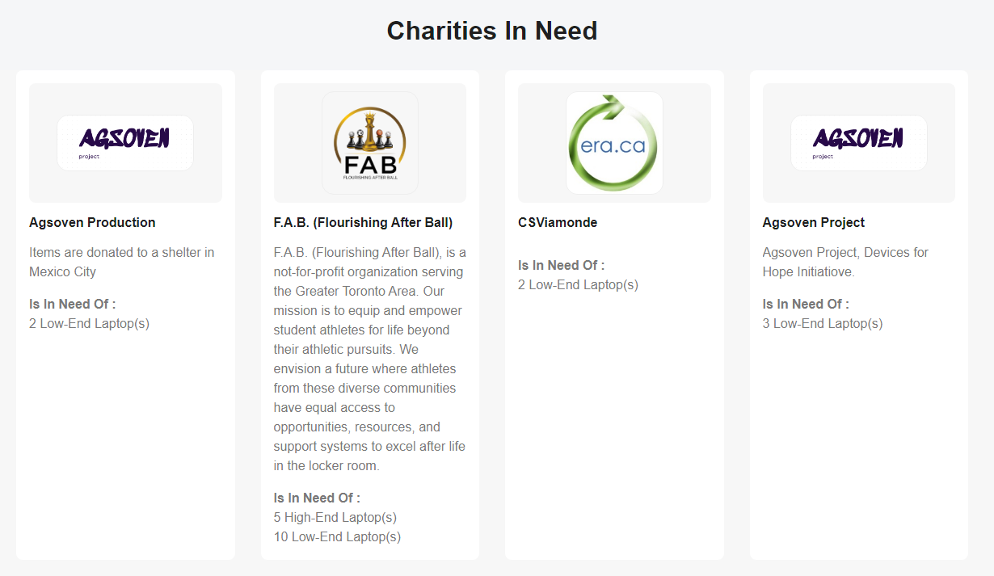

ERA also does a thing with schools. Where they educate the youth about e-waste. They teach students to be environmentally conscious when it comes to disposing of waste. Their presentation consists of the problem:

This is the discipline taught from the school presentations:

* Introduction to ERA
* What Happens When you Dispose of your Electronics?
* Did you know? Stats on the Environment in Canada
* Solution to the Growing Problem
* The 3 R Rule Video
* Reuse Vs Recycle
* Why Reuse?
* What’s your Tech Really Made of?
* The Problem with E-waste
* What Can You Do to Help
* Pop Quiz and Prizes

ERC Electronic Recycling Location inside of Toronto:

#15 489 Brimley Rd Toronto, ON, M1J 1A3.

Toll Free: 1-877-9EWASTE (392783)

416-477-0664

They also have many more locations all across Canada and USA.

ERA also host scholarships. Students could win up to $10,000 or even a macbook pro. They need someone to gather e-waste in your area and develop a marketing strategy. From the planning and promotion through the actual execution, you will oversee every element! They are interested in learning how innovatively the students can publicize the event and make connections with nearby businesses and the community. The ERA will assess your submissions following the deadline and select the winner once you have completed your collecting!

Reviews on Google :

x-

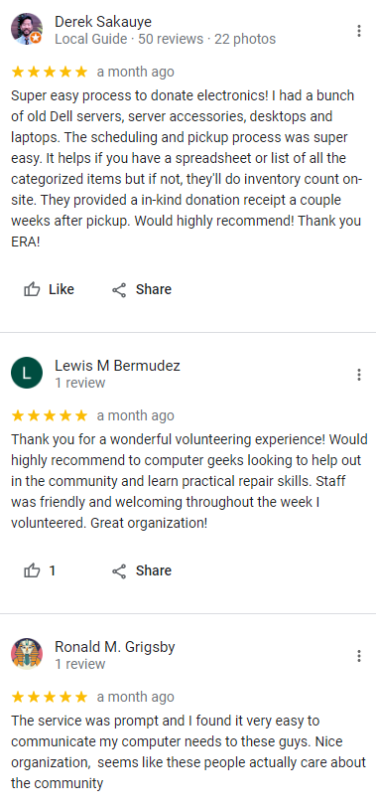

-------------------------------------------------------------------------------------------------------------------------------

Activity:

1. Separating the class into 2 groups

1. They elect 1 person to represent them.

1. They are able to answer a variety of questions about e-waste to test their knowledge. Such as being able to decide whether something is e-waste or not or a variety of other questions about e-waste.

1. The faster one to answer the question gets a point for their team and gets to stay up on stand.

1. The slower one gets booted off and then another person gets sent up to the front.

1. This repeats until there is no pictures left.

1. The team with the most amount of points wins.

Community partner:

<https://recyclemyelectronics.ca/on>

Government agency:

<https://www.canada.ca/en/environment-climate-change.html>

<https://www.canada.ca/en/environment-climate-change/news/2023/10/government-of-canada-commits-125-million-in-funding-in-new-collaboration-with-philanthropic-organizations-to-support-environmental-literacy-project.html>

<https://www.noaa.gov/office-education/noaa-education-council/monitoring-resources/common-measure-definitions/stewardship-definitions#:~:text=Definitions-,Environmental%20stewardship,et%20al.%2C%202010%20>).

------------------------

Sources (Government of Ontario) :

[Ontario Takes Action to Reduce Electronic Waste | Ontario Newsroom](https://news.ontario.ca/en/release/58898/ontario-takes-action-to-reduce-electronic-waste)

E-waste Meaning:

<https://en.wikipedia.org/wiki/Electronic_waste>

<https://www.nokia.com/about-us/news/releases/2020/10/22/nokia-and-greener-acres-canada-sign-agreement-to-advance-intelligent-urban-infrastructure-solutions/>

----------------------------------

EPRA :

[What is a Steward – EPRA | ARPE | Electronic Products Recycling Association | Association pour le recyclage des produits électroniques](https://epra.ca/what-is-a-steward)

[Home - Recycle My Electronics Ontario](https://recyclemyelectronics.ca/on)

<https://epra.ca/wp-content/uploads/2016/04/EPRA-SK-Takeback-to-Touchdown-Award-Release-FINAL-v2.pdf>

<https://www.google.com/maps/place/Recycle+My+Electronics/@43.601096,-79.623289,12z/data=!4m6!3m5!1s0x882b391c99384c0f:0x7f7fa8ee83e0e8f8!8m2!3d43.6565695!4d-79.6152048!16s%2Fg%2F11l_gwb6mf?entry=ttu>

<https://www.google.com/search?q=recycle+my+electronics&rlz=1C1ONGR_enCA934CA934&oq=Recycle+My+Electronics&gs_lcrp=EgZjaHJvbWUqBwgAEAAYgAQyBwgAEAAYgAQyEAgBEC4YrwEYxwEYgAQYjgUyBwgCEAAYgAQyBwgDEAAYgAQyBwgEEAAYgAQyBggFEEUYPDIGCAYQRRg9MgYIBxBFGDzSAQgxOTg5ajBqN6gCALACAA&sourceid=chrome&ie=UTF-8>

[Electronic Products Recycling Association wins Canadian Stewardship Award | Information Technology Association of Canada (itac.ca)](https://itac.ca/blog/electronic-products-recycling-association-wins-canadian-stewardship-award/)

[EPRA_Report_to_Director_2021.pdf (recyclemy-assets.com)](https://www.recyclemy-assets.com/2022/06/EPRA_Report_to_Director_2021.pdf)

-----------------

ERA

<https://www.era.ca/>

[https://www.era.ca/about-us/?_gl=1*89l0ik*_gcl_au*MTIzNzMxMzM3Ny4xNjk5MjMwMjI5&_ga=2.110055877.1732569958.1699230229-1277123778.1699230229](https://www.era.ca/about-us/?_gl=1*89l0ik*_gcl_au*MTIzNzMxMzM3Ny4xNjk5MjMwMjI5&_ga=2.110055877.1732569958.1699230229-1277123778.1699230229)

<https://www.google.com/maps/place/Electronic+Recycling+Association/@43.7338068,-79.2452373,15z/data=!3m1!4b1!4m7!3m6!1s0x89d4ce2cd36d1ed7:0x8a9708d1718c8f1a!8m2!3d43.7338068!4d-79.2452373!15sCgNFUkFaBSIDZXJhkgEQcmVjeWNsaW5nX2NlbnRlcpoBJENoZERTVWhOTUc5blMwVkpRMEZuU1VSRE56VlFiVEZSUlJBQuABAA!16s%2Fg%2F11gfk5l3rv?entry=ttu>

<https://www.era.ca/school-presentation/>

# **Bibliography**

[1]

Government of canada, “Environment and Climate Change Canada - Canada.ca,” *Canada.ca*, 2018. https://www.canada.ca/en/environment-climate-change.html

[2]

E. and C. C. Canada, “Government of Canada commits $12.5 million in funding in new collaboration with philanthropic organizations to support environmental literacy projects across Canada,” *www.canada.ca*, Oct. 04, 2023. https://www.canada.ca/en/environment-climate-change/news/2023/10/government-of-canada-commits-125-million-in-funding-in-new-collaboration-with-philanthropic-organizations-to-support-environmental-literacy-project.html (accessed Nov. 07, 2023).

[3]

“Ontario Newsroom | Salle de presse de l’Ontario,” *news.ontario.ca*. https://news.ontario.ca/en/release/58898/ontario-takes-action-to-reduce-electronic-waste

[4]

Wikipedia Contributors, “Electronic waste,” *Wikipedia*, Mar. 12, 2019. https://en.wikipedia.org/wiki/Electronic_waste

[5]

“What is a Steward – EPRA | ARPE | Electronic Products Recycling Association | Association pour le recyclage des produits électroniques,” *Epra.ca*, 2014. https://epra.ca/what-is-a-steward

[6]

“Home,” *Recycle My Electronics*. https://recyclemyelectronics.ca/on (accessed Nov. 07, 2023).

[7]

“EPRA Saskatchewan and the Saskatchewan Roughriders Take Being Green to a New Award Winning Level.” Accessed: Nov. 07, 2023. [Online]. Available: https://epra.ca/wp-content/uploads/2016/04/EPRA-SK-Takeback-to-Touchdown-Award-Release-FINAL-v2.pdf

[8]

“Home,” *Recycle My Electronics*. https://recyclemyelectronics.ca/on (accessed Nov. 07, 2023).

[9]

“EPRA Saskatchewan and the Saskatchewan Roughriders Take Being Green to a New Award Winning Level.” Accessed: Nov. 07, 2023. [Online]. Available: https://epra.ca/wp-content/uploads/2016/04/EPRA-SK-Takeback-to-Touchdown-Award-Release-FINAL-v2.pdf

[10]

“Google Maps,” *Google Maps*. https://www.google.com/maps/place/Recycle+My+Electronics/@43.601096 (accessed Nov. 07, 2023).

[11]

“recycle my electronics - Google Search,” *www.google.com*. https://www.google.com/search?q=recycle+my+electronics&rlz=1C1ONGR_enCA934CA934&oq=Recycle+My+Electronics&gs_lcrp=EgZjaHJvbWUqBwgAEAAYgAQyBwgAEAAYgAQyEAgBEC4YrwEYxwEYgAQYjgUyBwgCEAAYgAQyBwgDEAAYgAQyBwgEEAAYgAQyBggFEEUYPDIGCAYQRRg9MgYIBxBFGDzSAQgxOTg5ajBqN6gCALACAA&sourceid=chrome&ie=UTF-8 (accessed Nov. 07, 2023).

[12]

“Electronic Products Recycling Association wins Canadian Stewardship Award | Information Technology Association of Canada,” *itac.ca*. https://itac.ca/blog/electronic-products-recycling-association-wins-canadian-stewardship-award/ (accessed Nov. 07, 2023).

[13]

C. Wisehart, “Electronic Products Recycling Association Annual Report to the Director [2021 Calendar Year],” 2022. Accessed: Nov. 07, 2023. [Online]. Available: https://www.recyclemy-assets.com/2022/06/EPRA_Report_to_Director_2021.pdf

[14]

B. A. info @bb.agency, “Computer Recycling Vancouver Calgary Edmonton Saskatoon Winnipeg Toronto Montreal,” *Electronic Recycling Association Computer Recycling and Donations*. https://www.era.ca/

[15]

B. A. info @bb.agency, “About Us,” *Electronic Recycling Association Computer Recycling and Donations*. https://www.era.ca/about-us/?_gl=1

[16]

“Google Maps,” *Google Maps*. https://www.google.com/maps/place/Electronic+Recycling+Association/@43.7338068 (accessed Nov. 07, 2023).

[17]

B. A. info @bb.agency, “School Presentation,” *Electronic Recycling Association Computer Recycling and Donations*. https://www.era.ca/school-presentation/ (accessed Nov. 07, 2023).